**CNS ASSIGNMENT**

**NAME & ROLL NO.**

20BEC022 – DEKSHITHAA R M

20BEC054 – YALINI SHREE P V

**CONTENT**

Deliberate software attacks occur when an individual or group designs and deploys software to attack a system. Most of this software is referred to as malicious code or malicious software, or sometimes malware. These software components or programs are designed to damage, destroy, or deny service to the target systems. Some of the more common instances of malicious code are viruses and worms, Trojan horses, logic bombs, and back doors.

**HASH GENERATOR SCREEN SHOT**

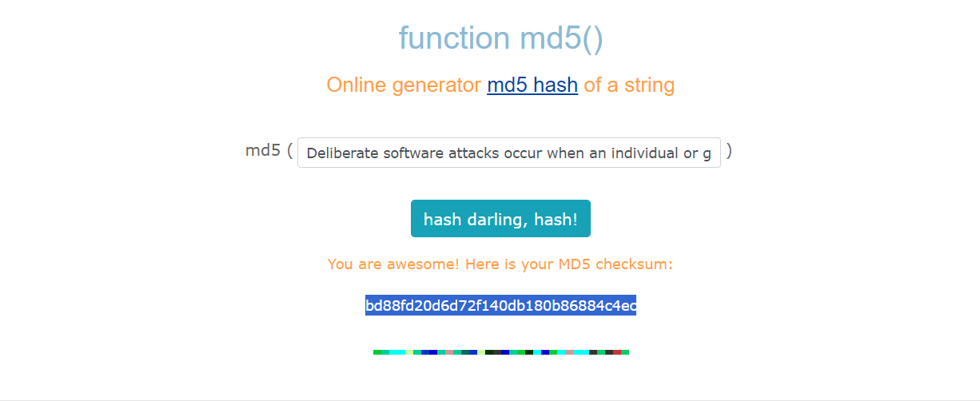

**GENERATED HASH CODE**

bd88fd20d6d72f140db180b86884c4ec